Spring container

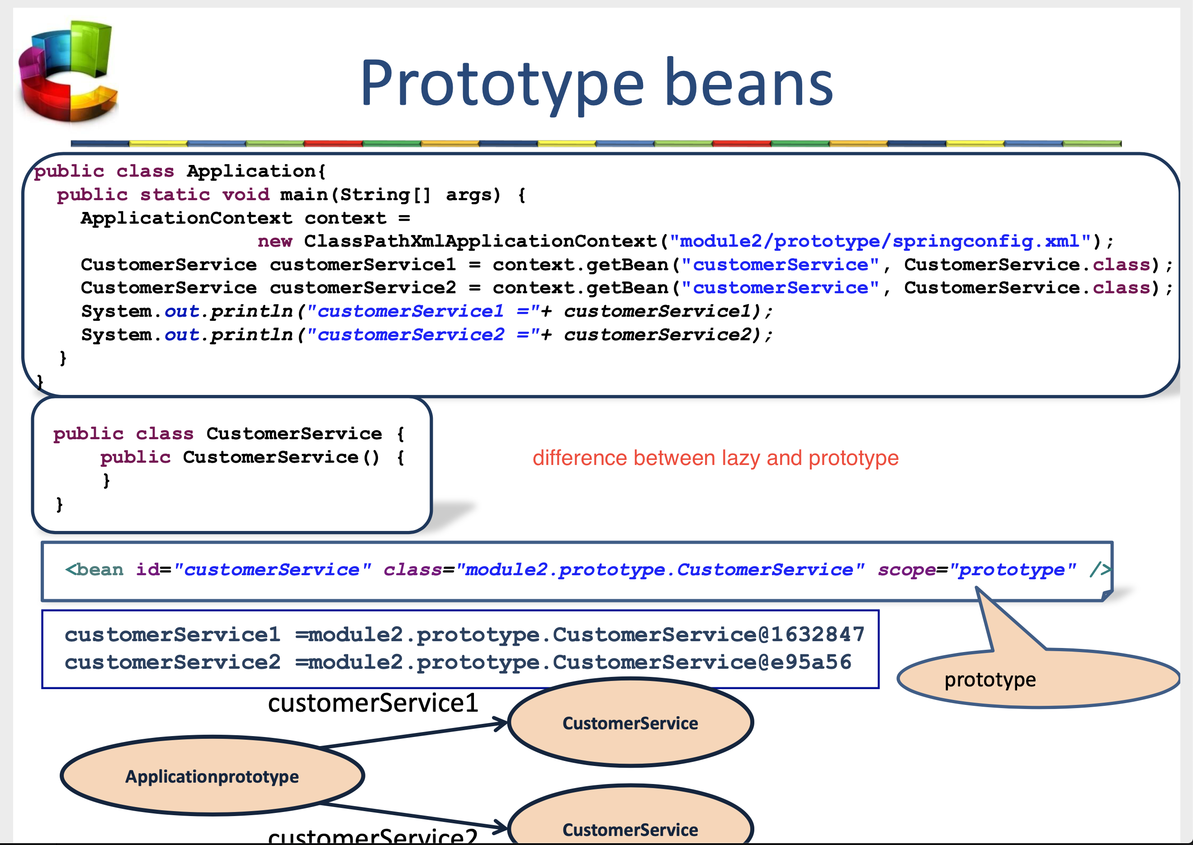

Prototype creates a new instance (scope=prototype)

By the default are singleton and eager

Lazy the **bean** will only be created, and its dependencies injected, once they're needed

Dependency injection

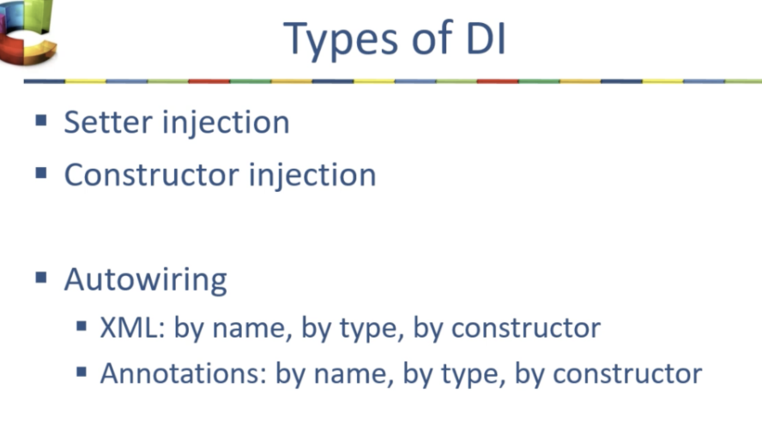

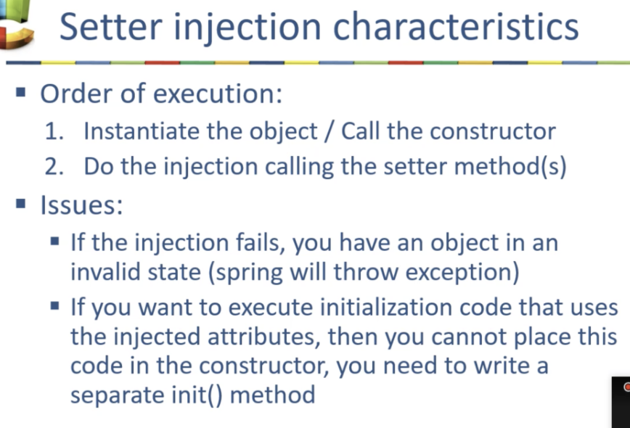

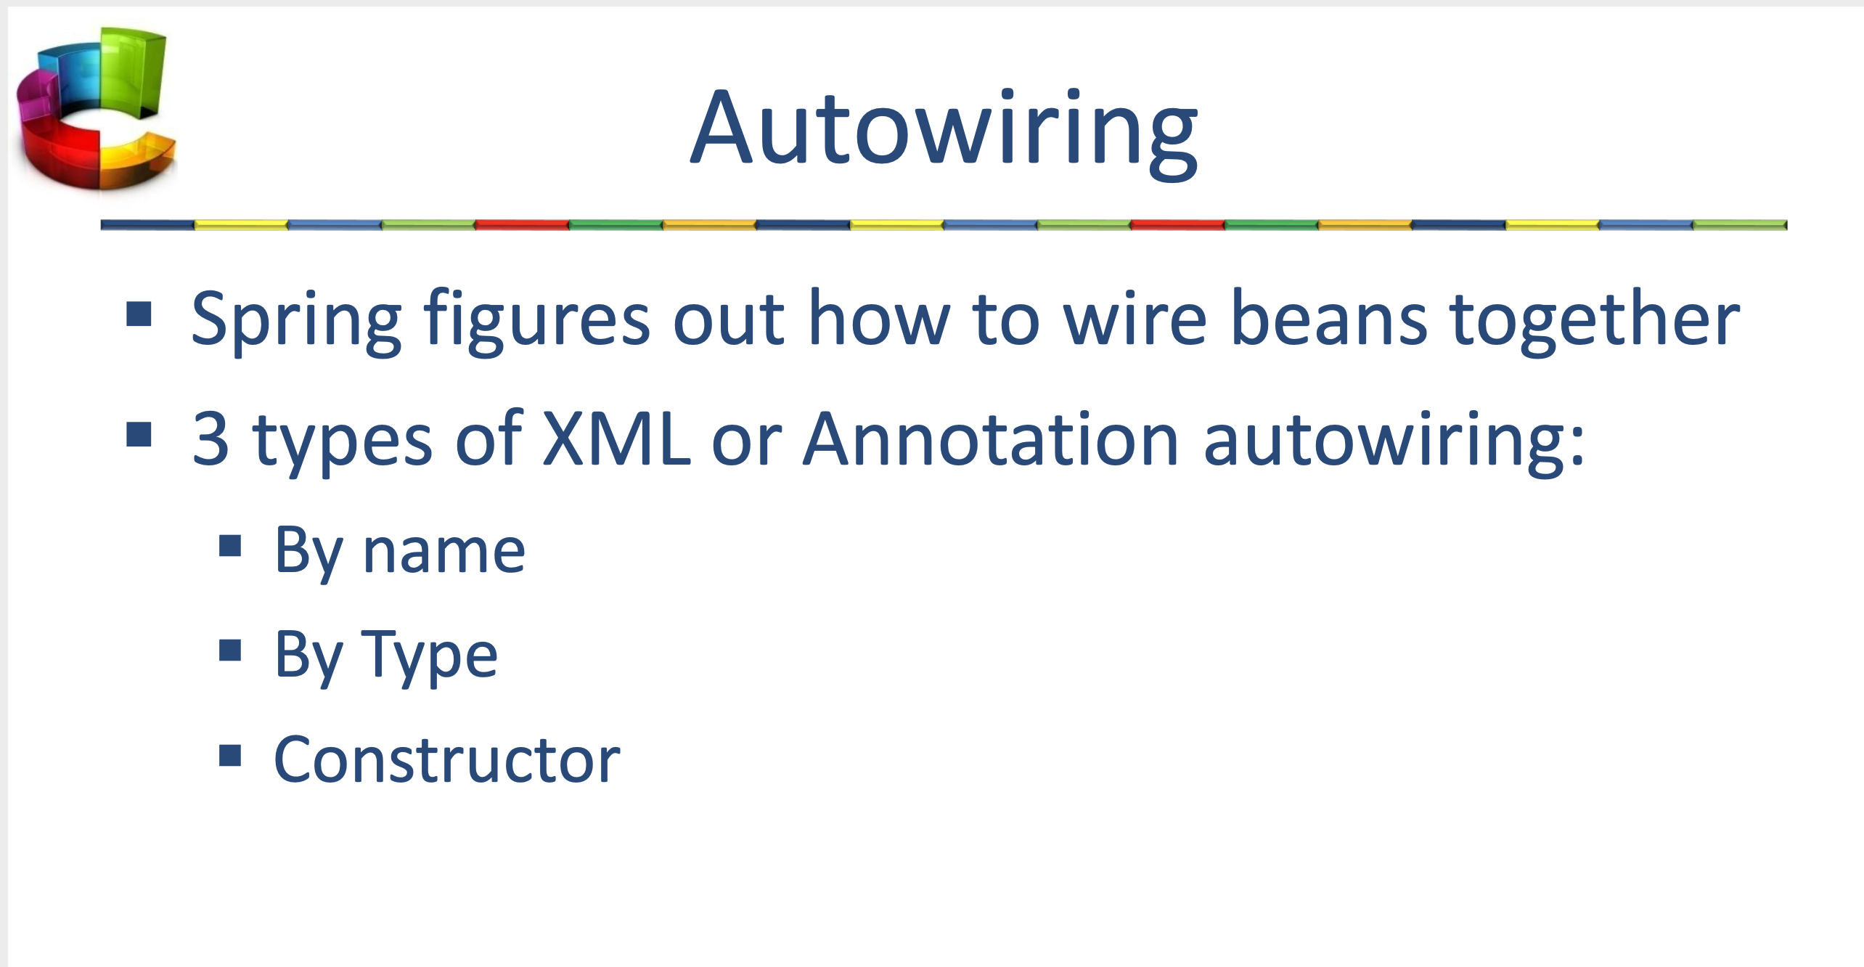

By name: if the name of a bean is same as the name of other bean property, auto wire it.

By type: if data type of a bean is compatible with the data type of other bean property, auto wire it.

Constructor.- similar to *byType*, but it applies to constructor arguments

Field injection vs property injection

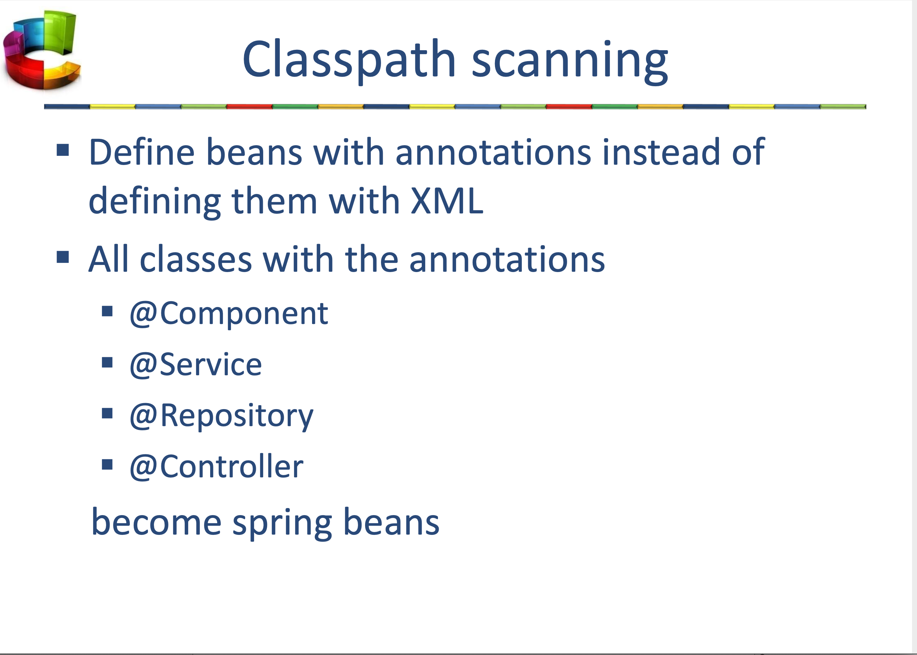

AOP

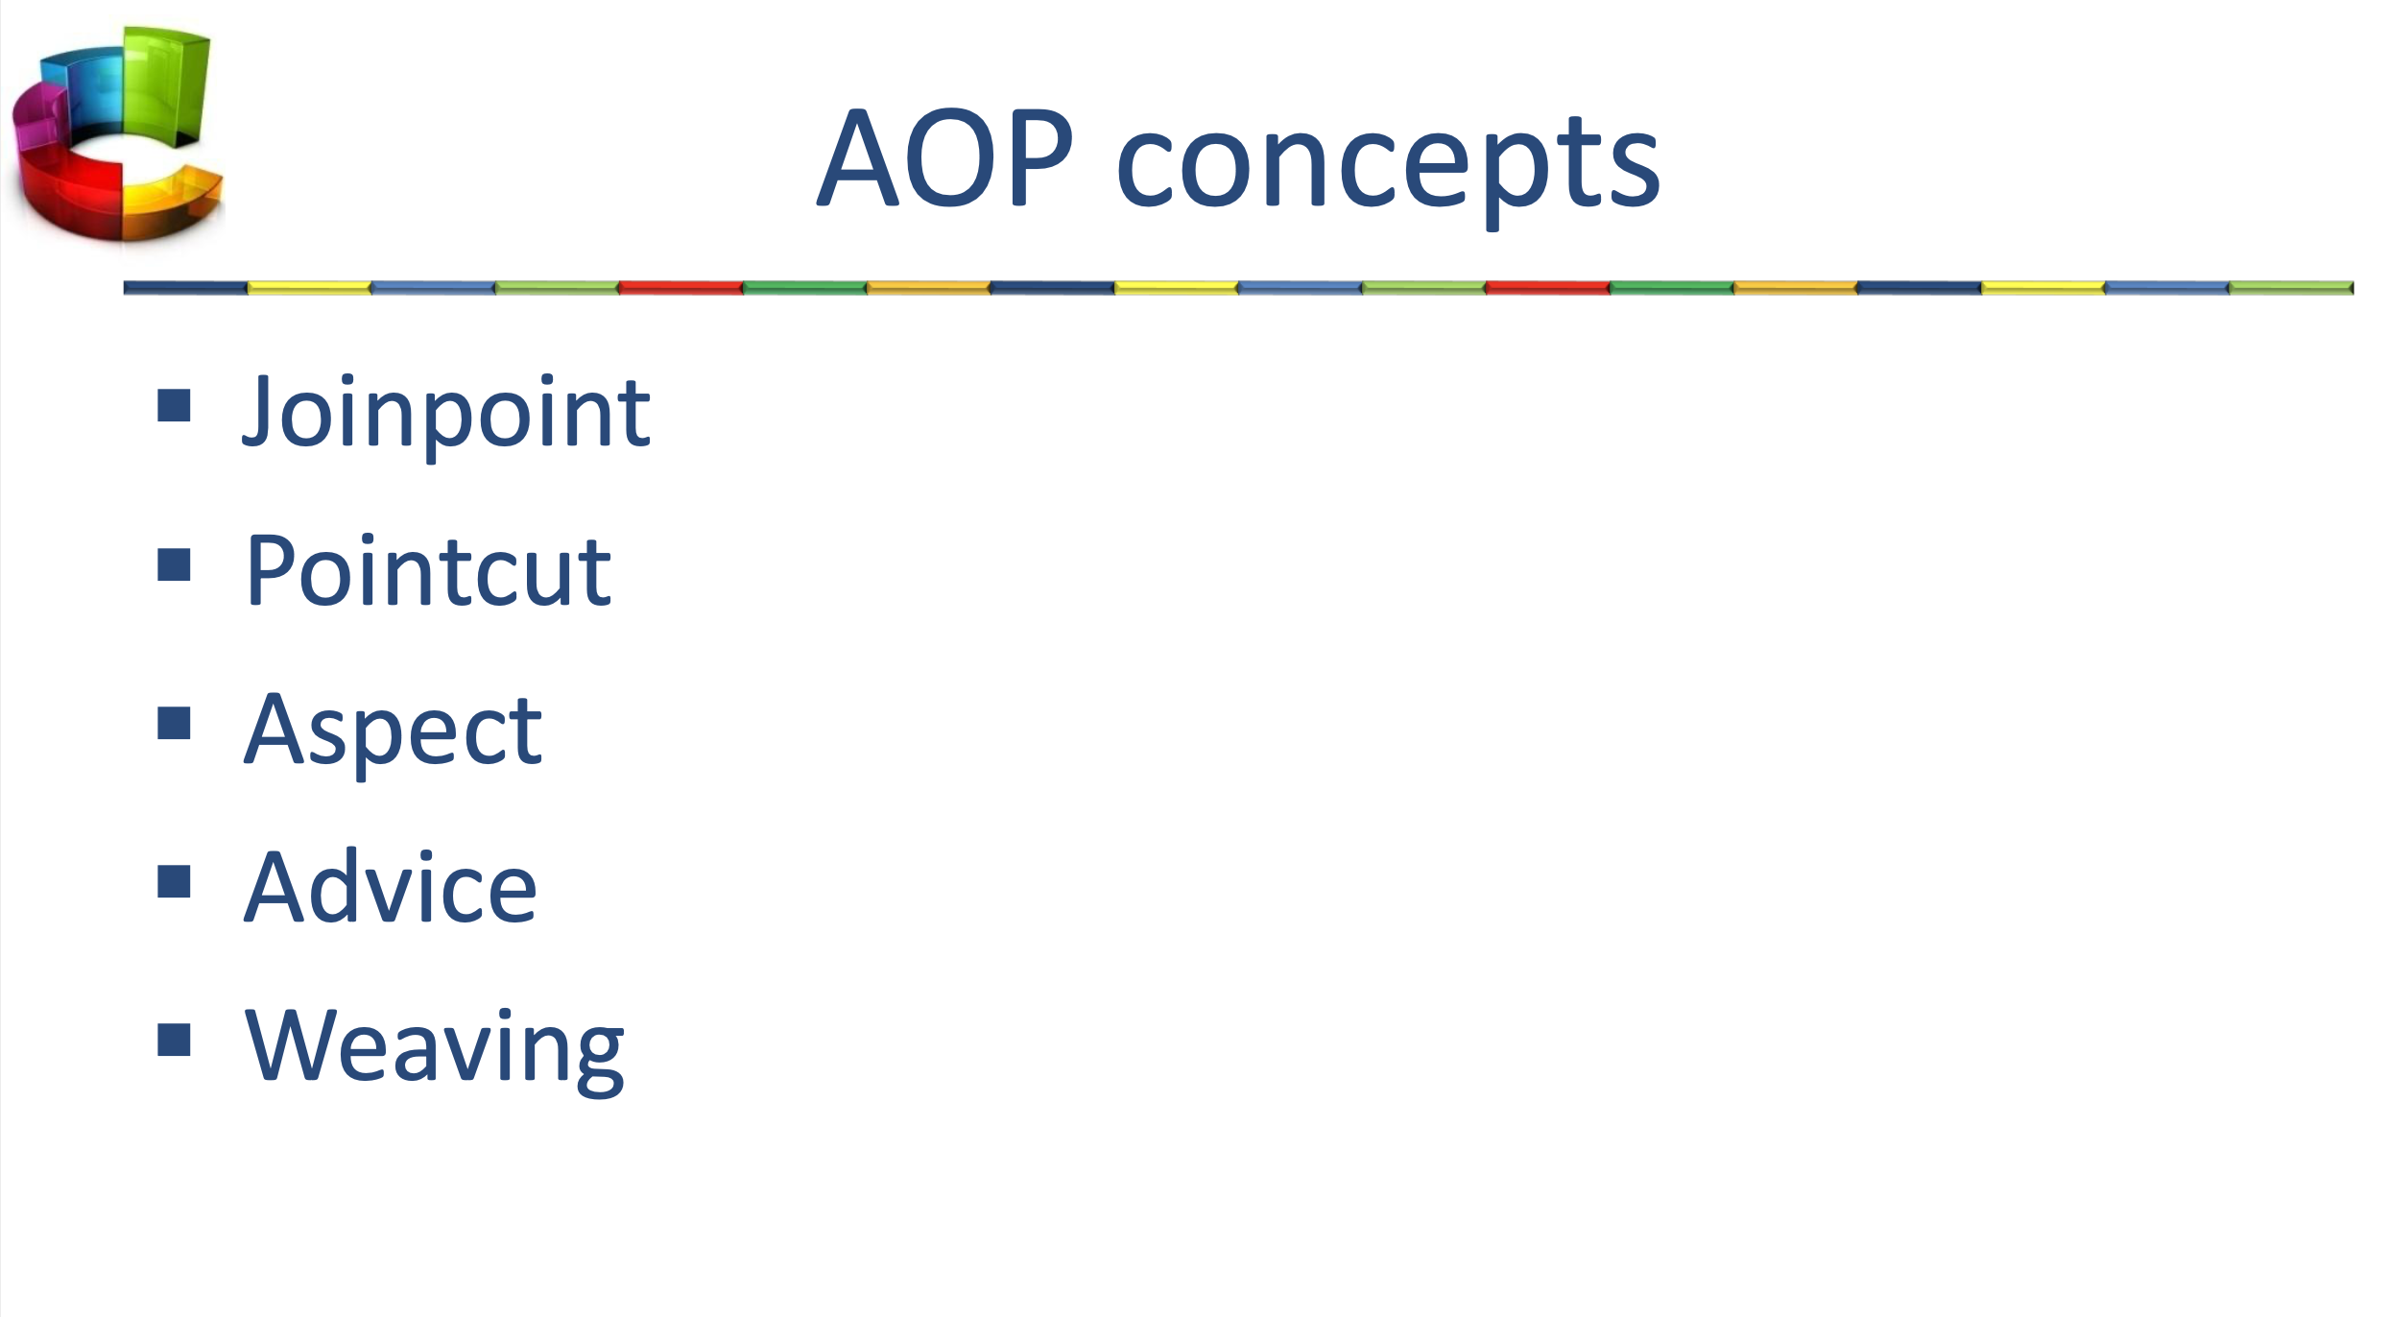

Joinpoint.- A specific point in the code

Pointcut.- A collection of 1 or more joinpoints

Aspect.- concern that cuts across multiple classes

Advice.- action taken by an aspect at a particular join point

Weaving.- linking aspects with other application types or objects to create an advised object

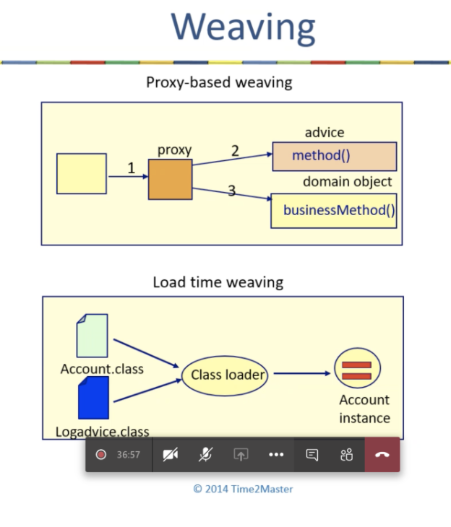

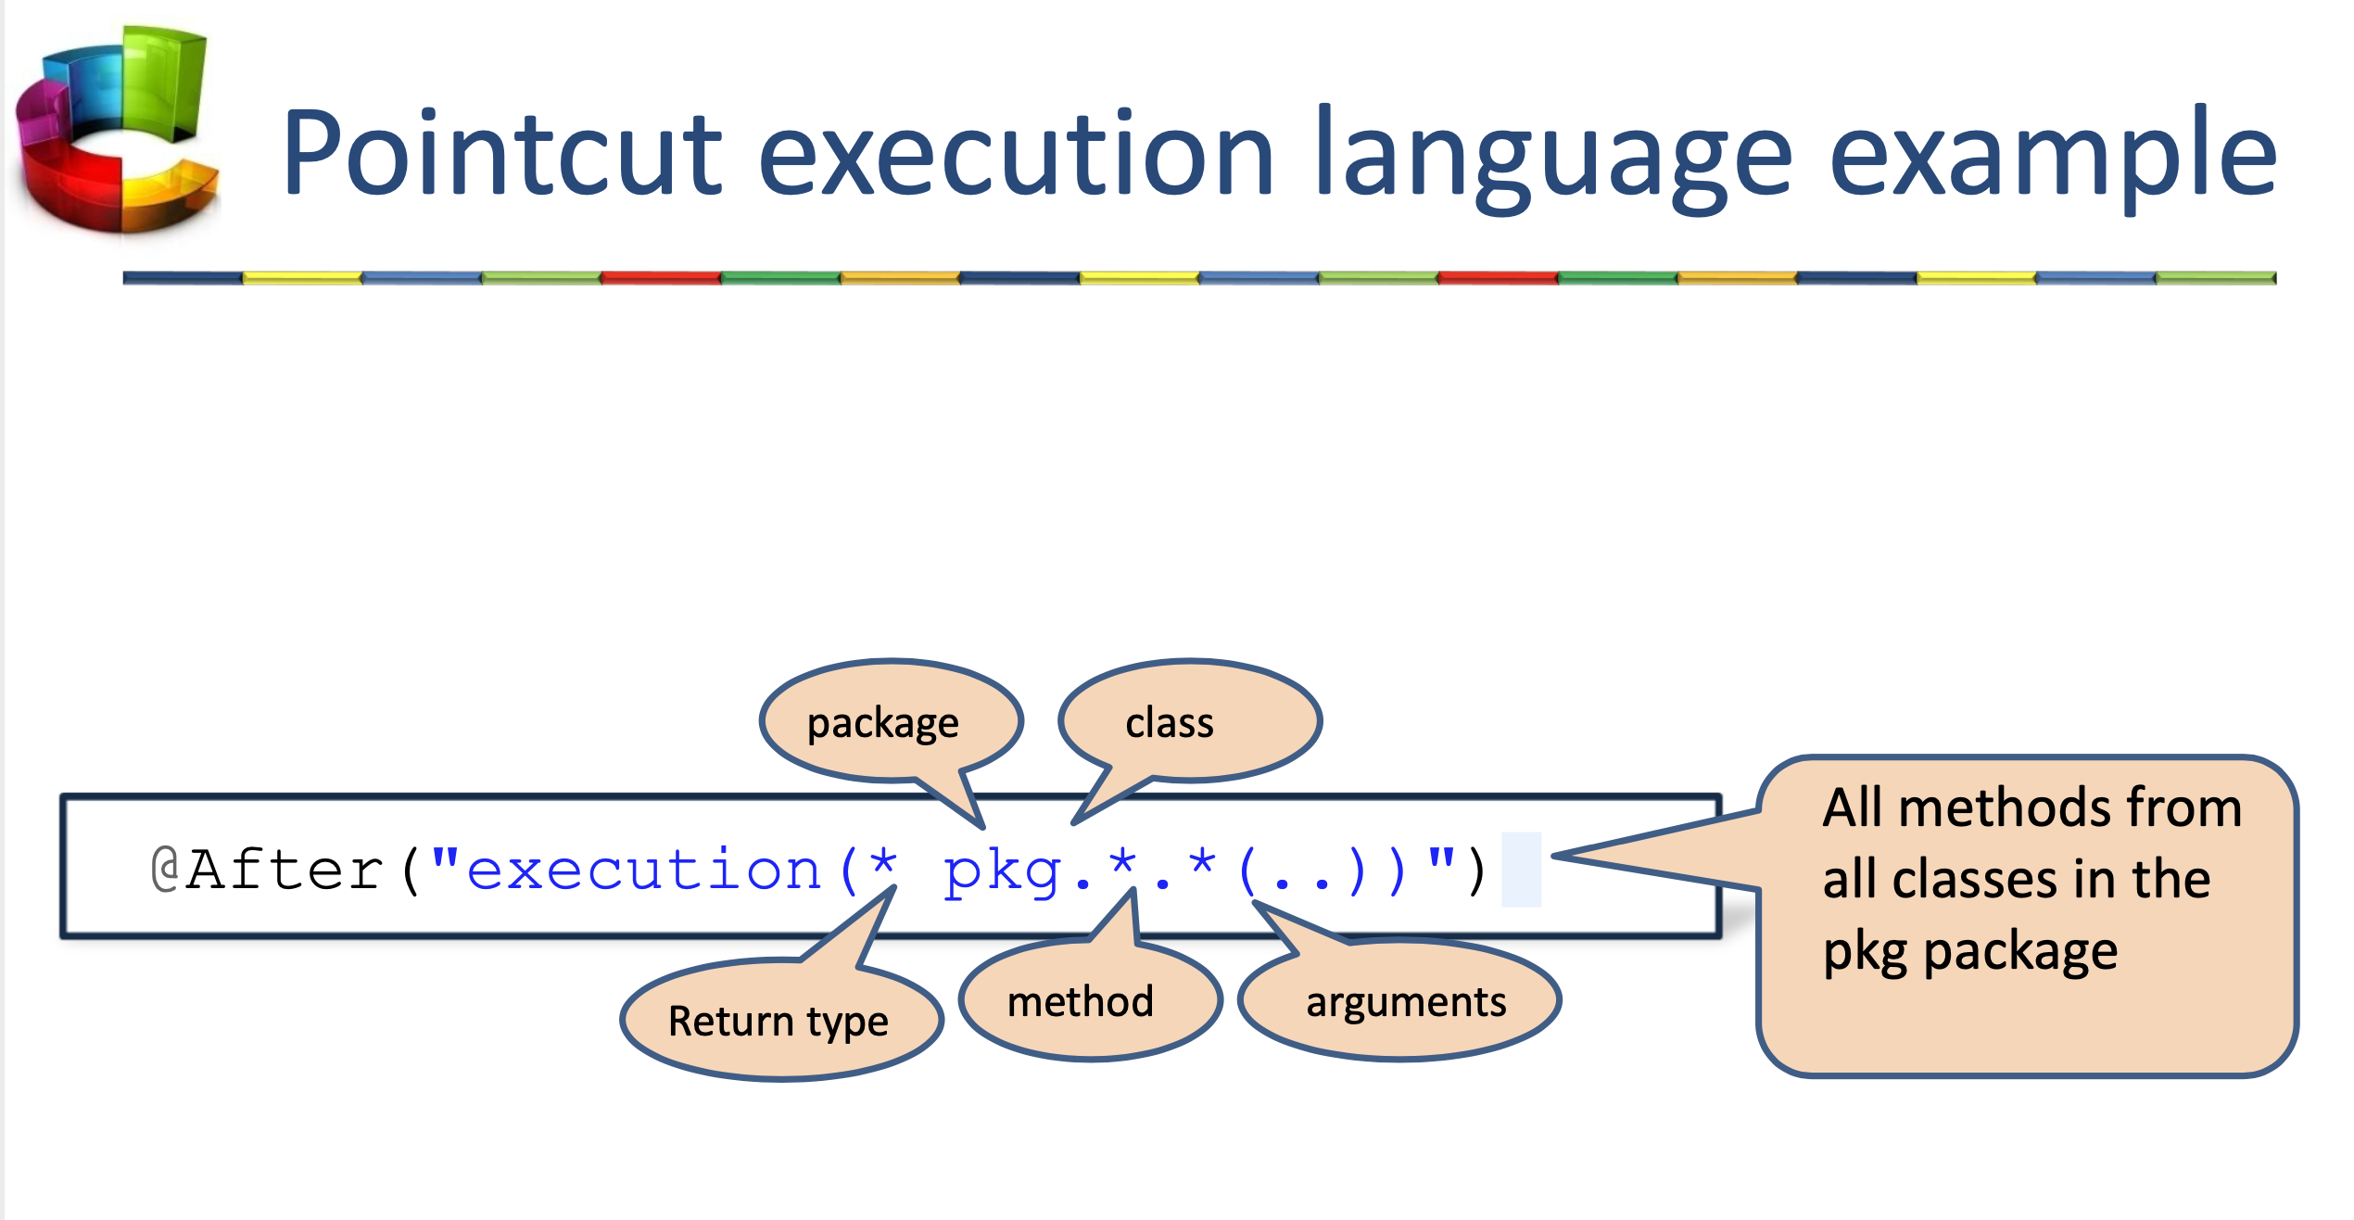

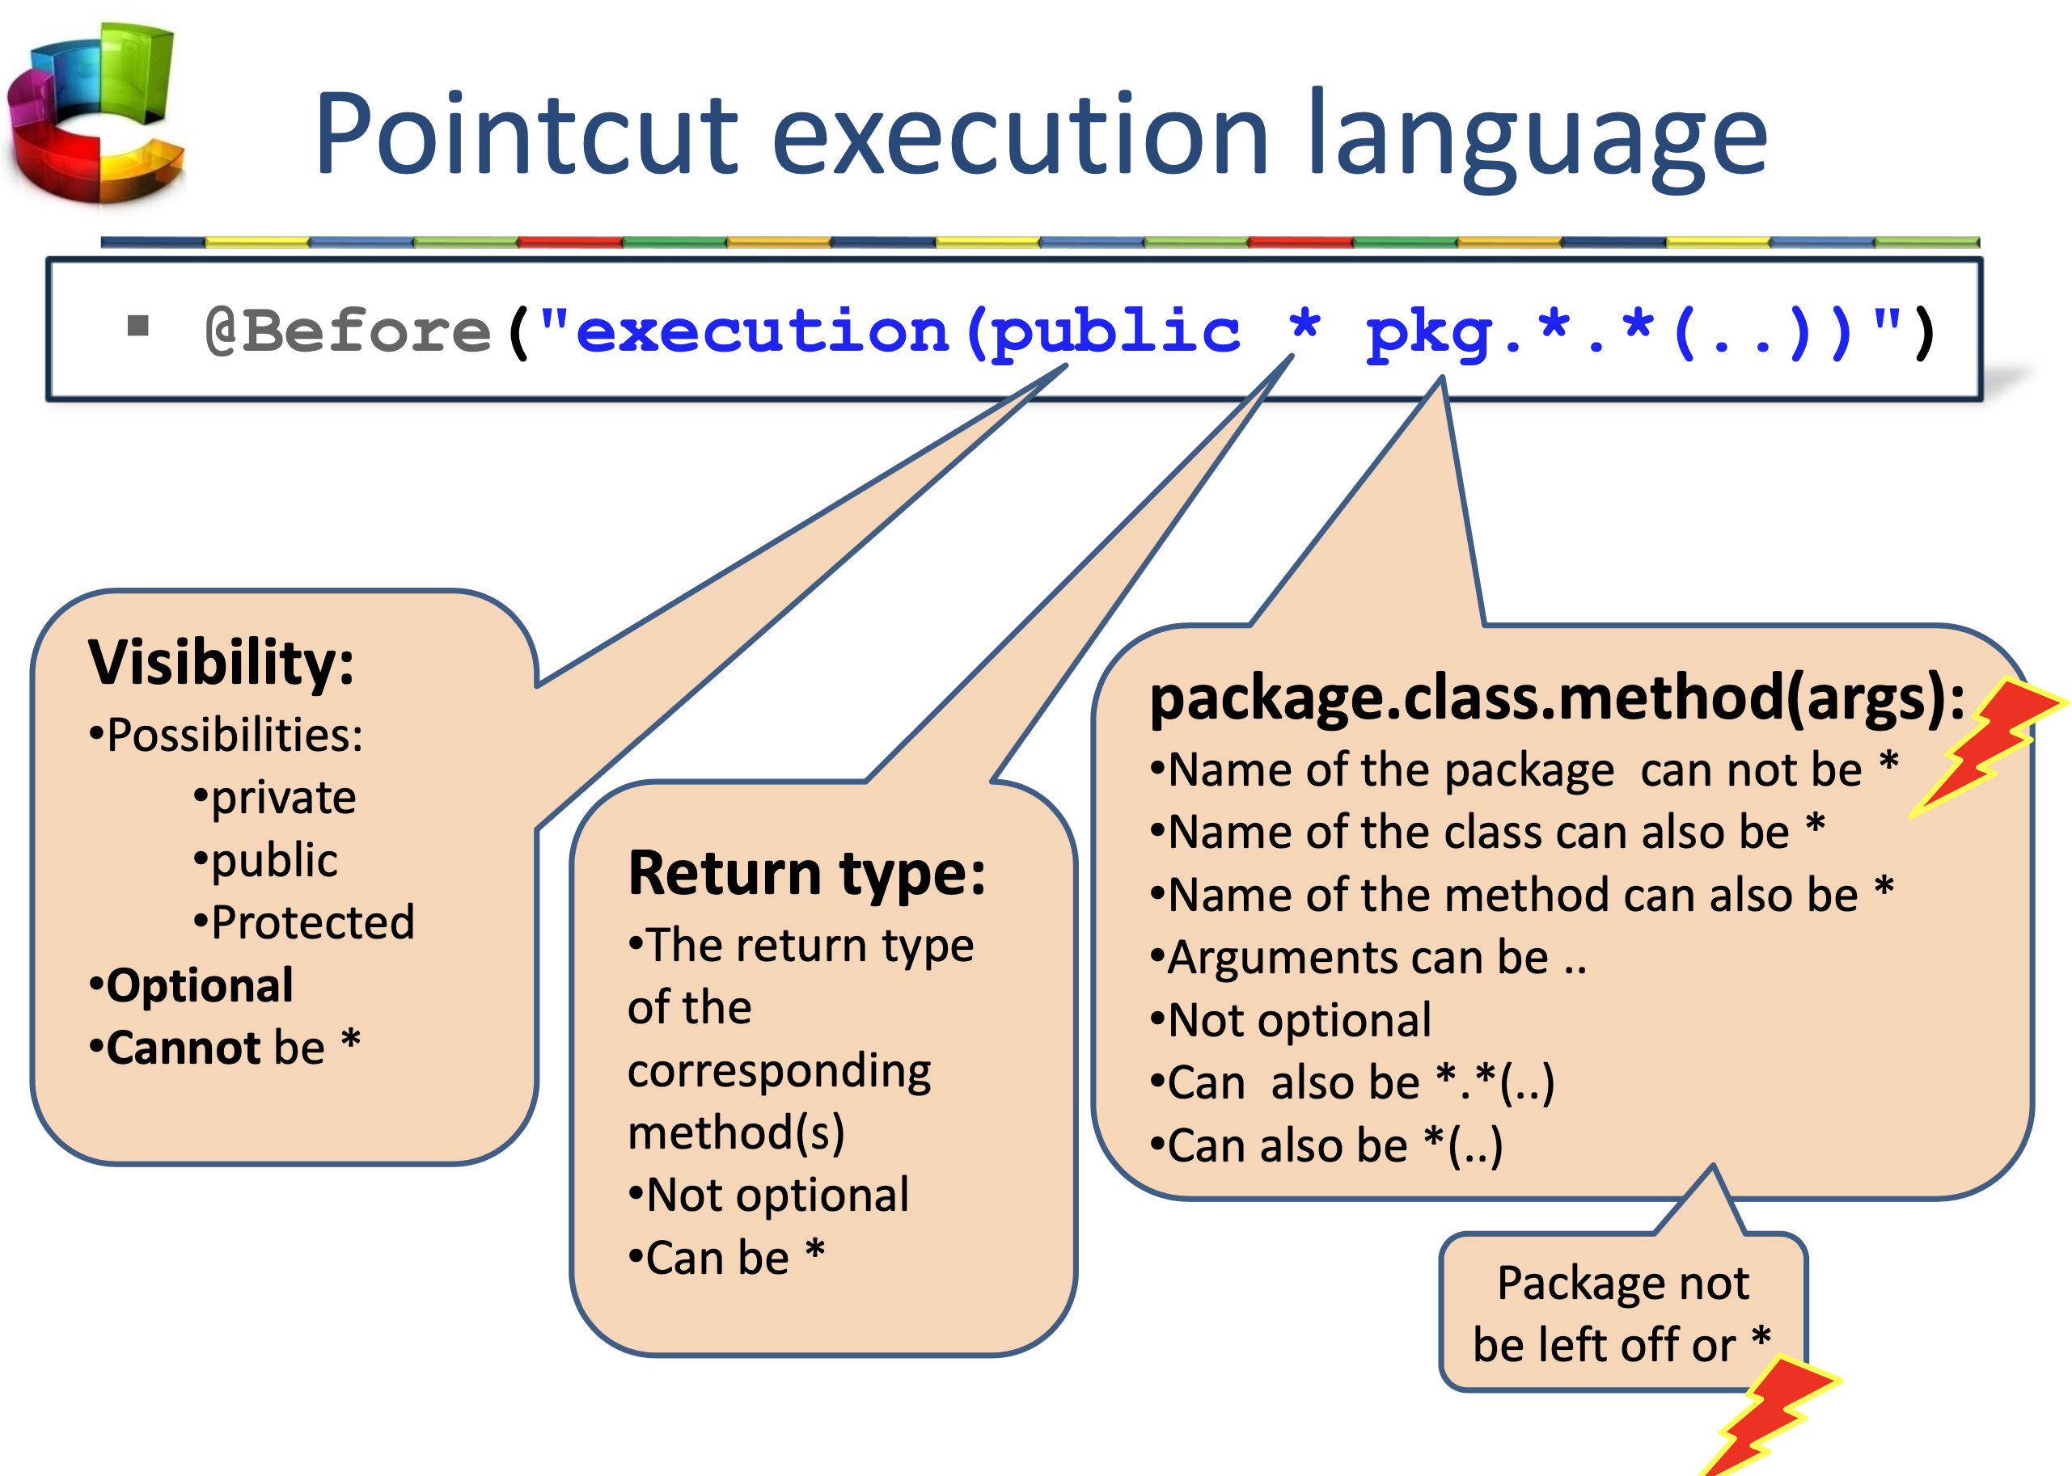

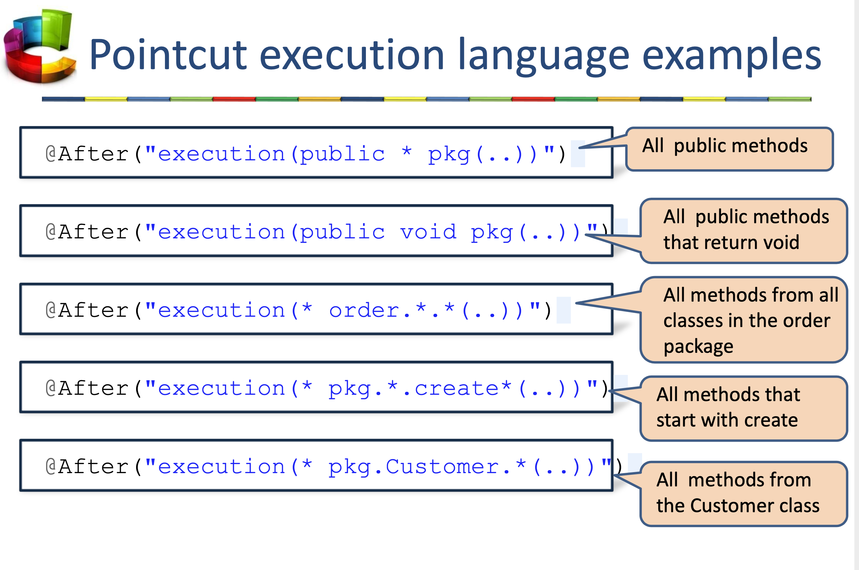

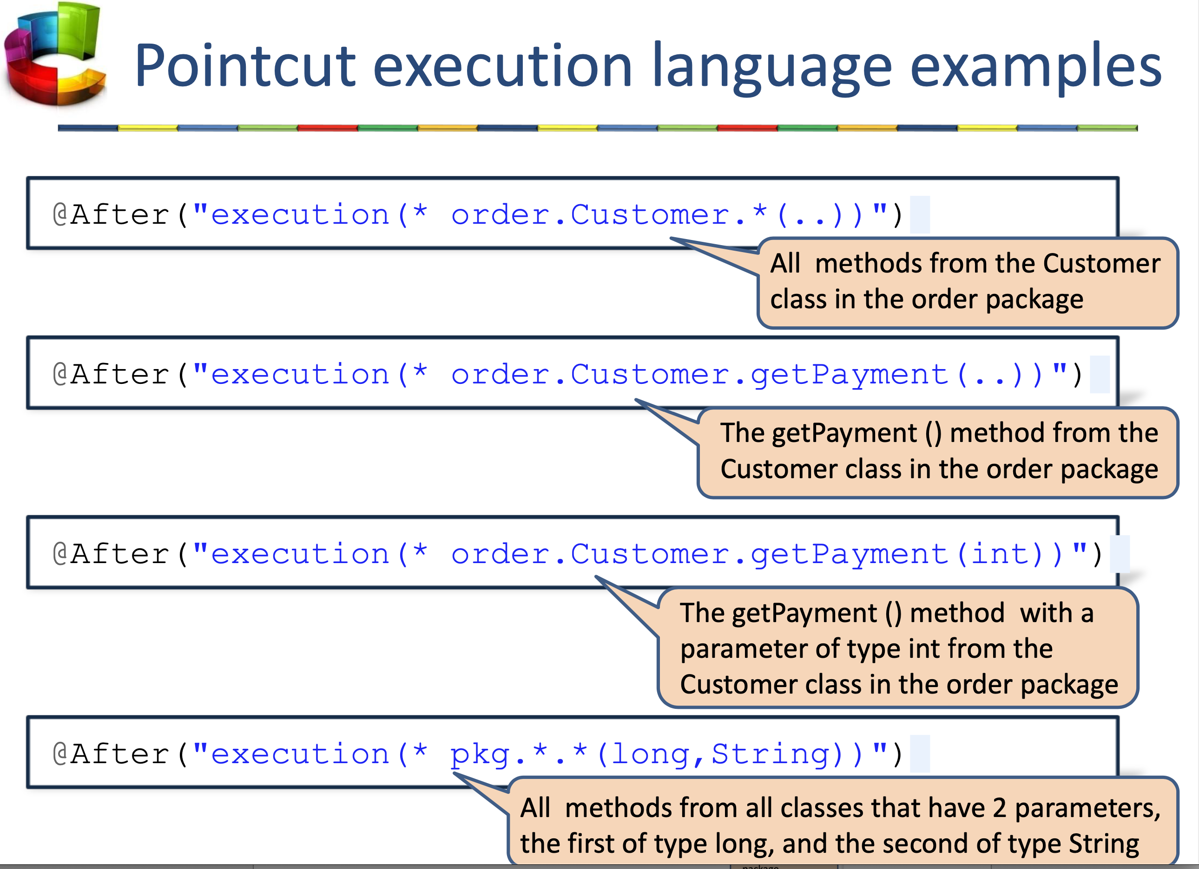

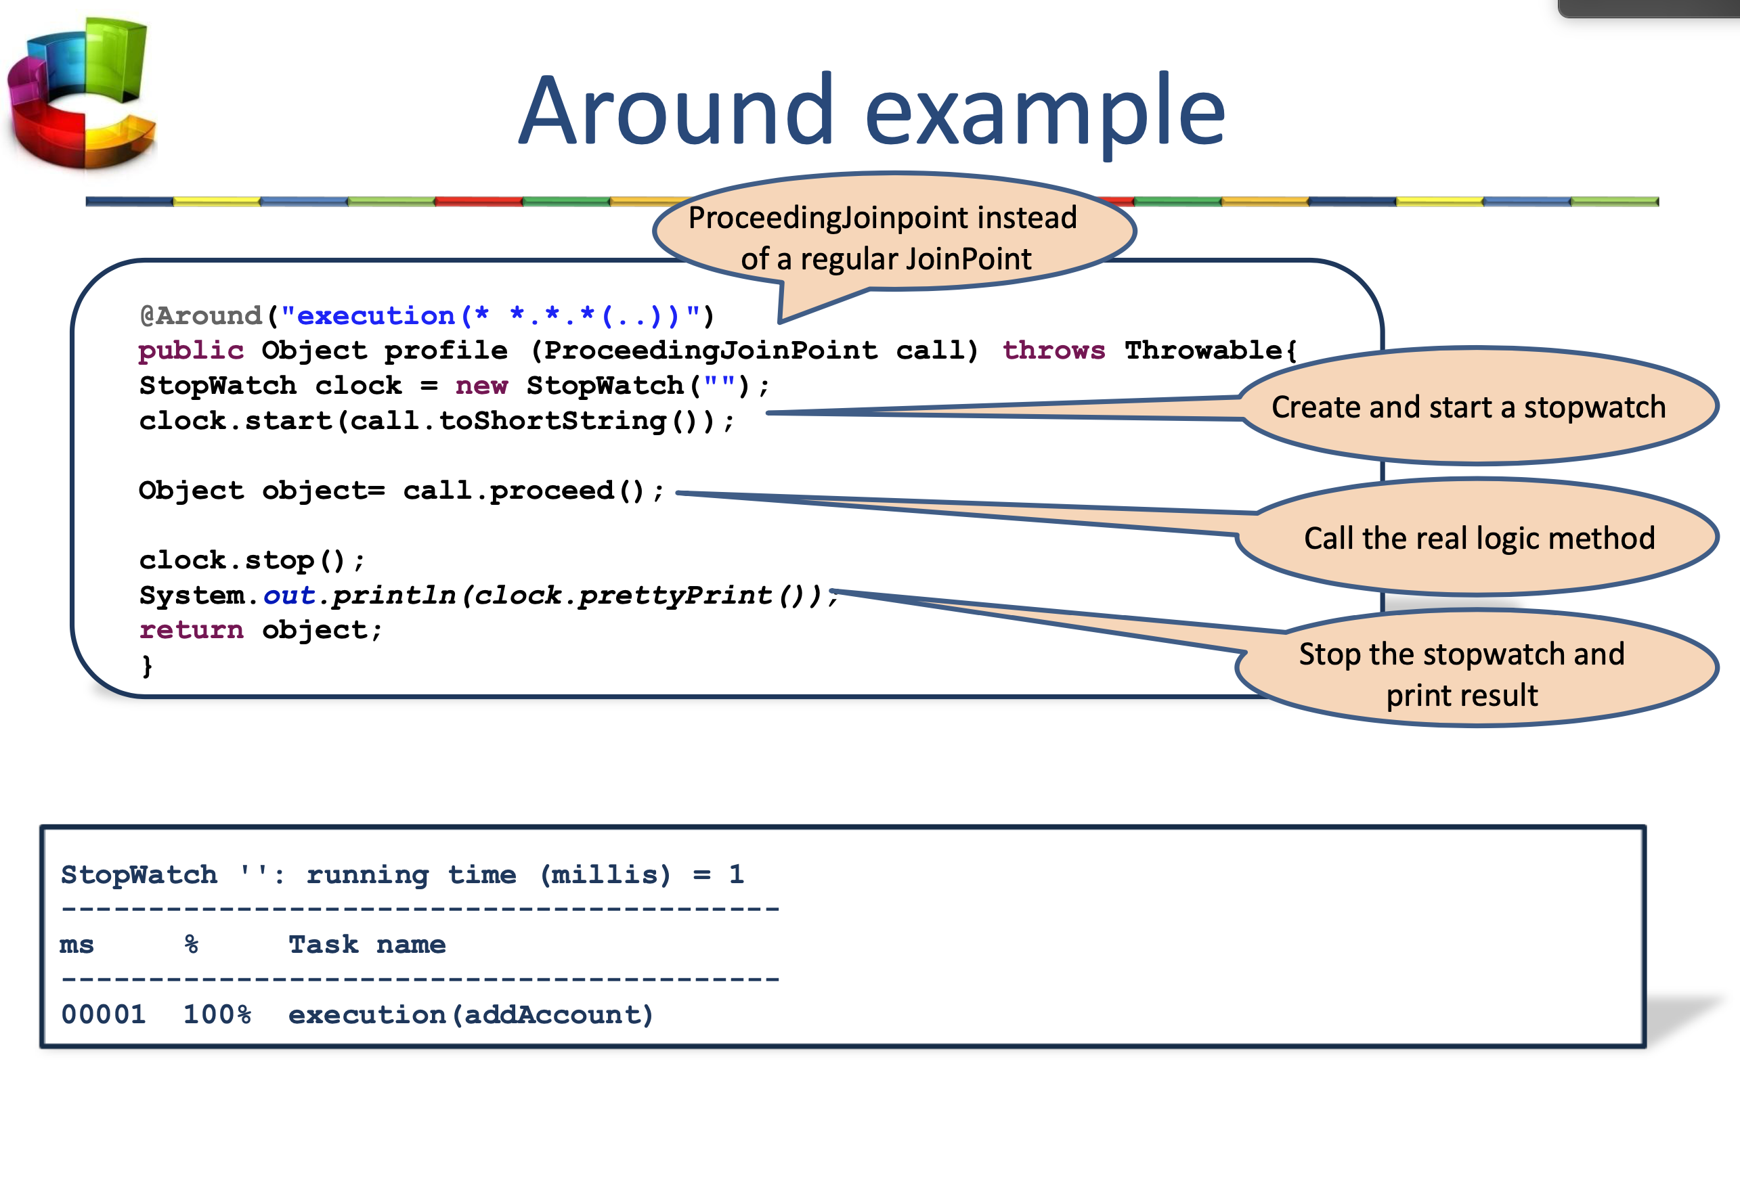

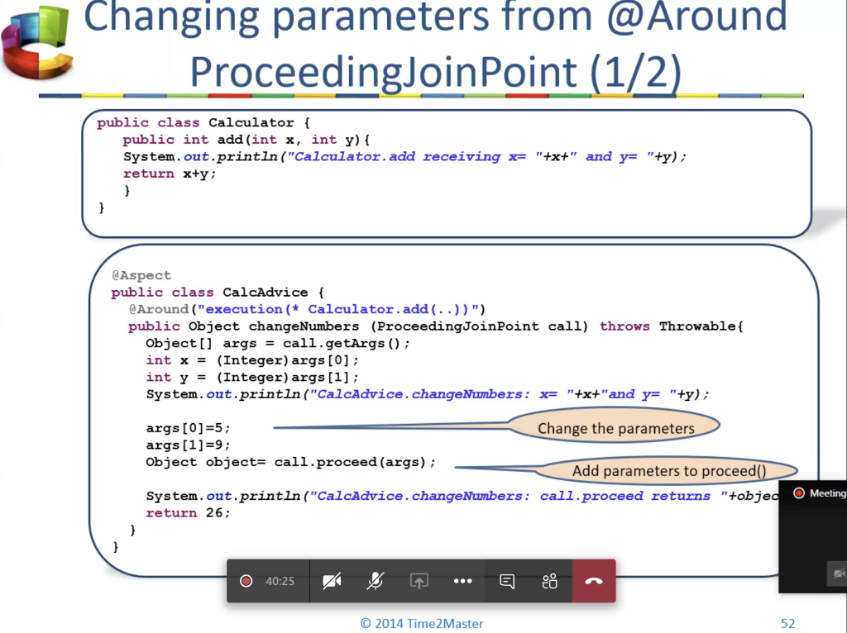

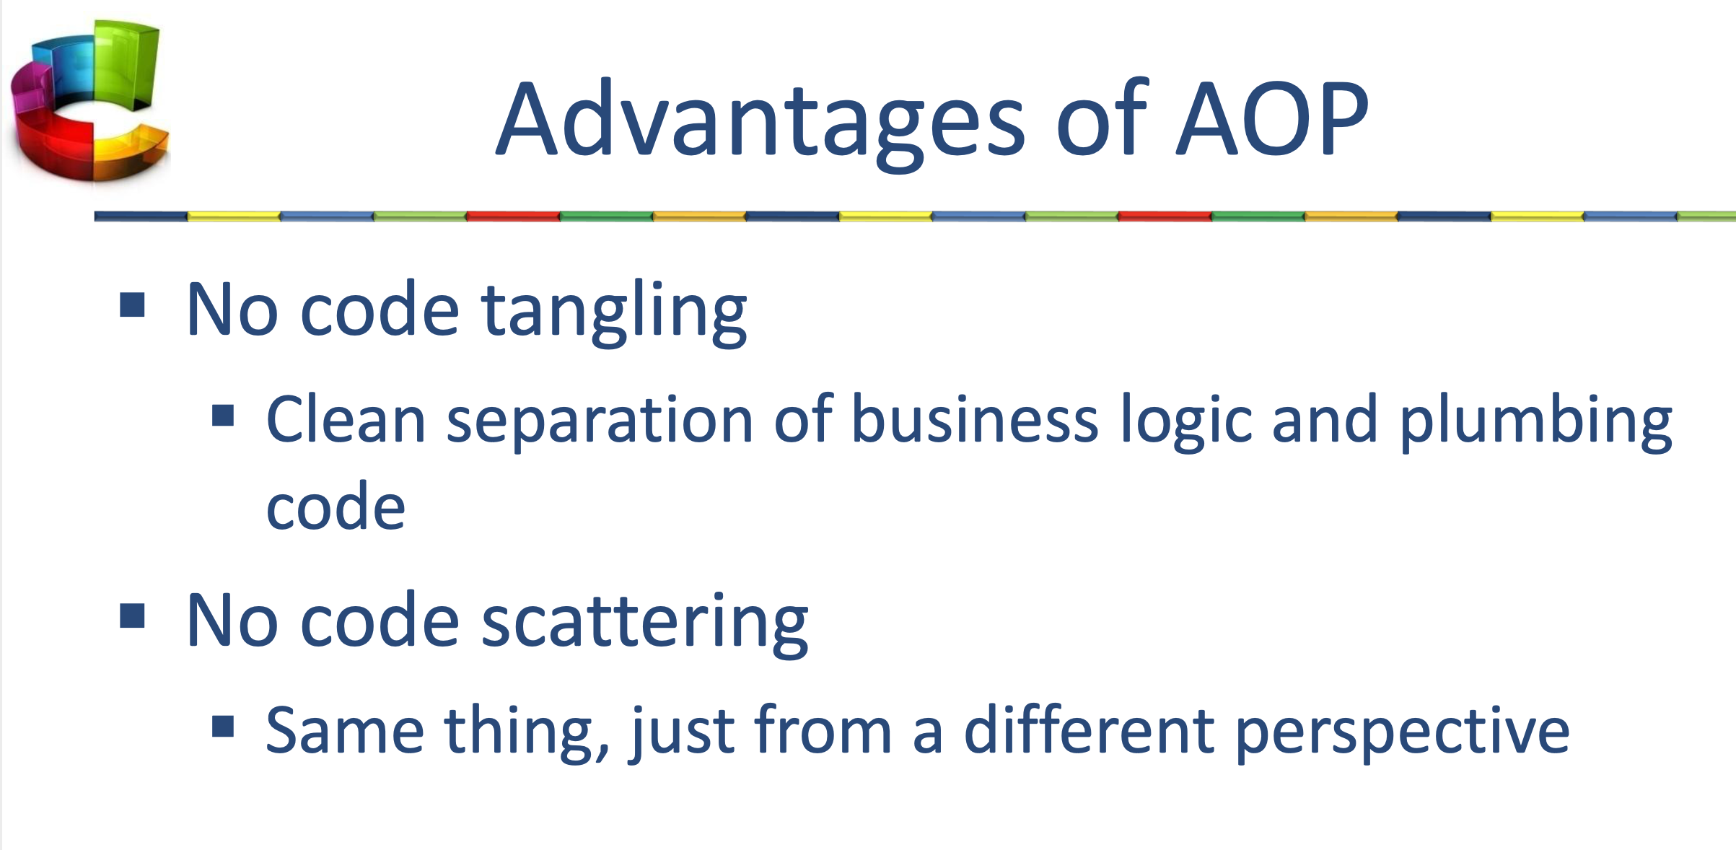

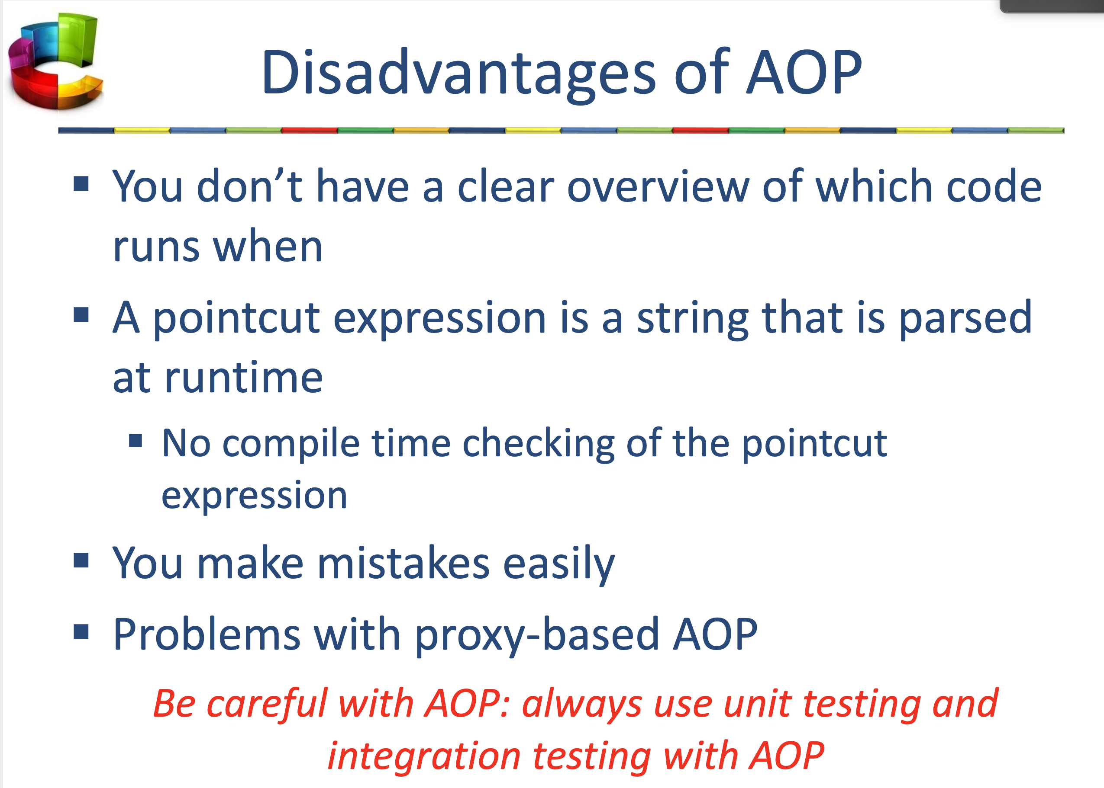

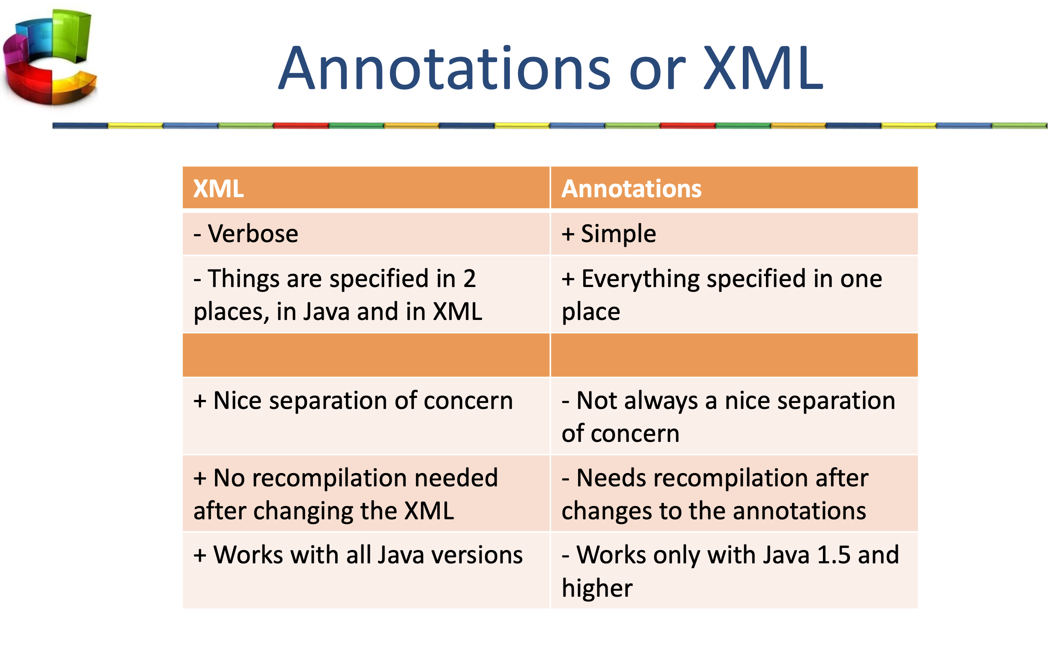

18 Spring Transactions

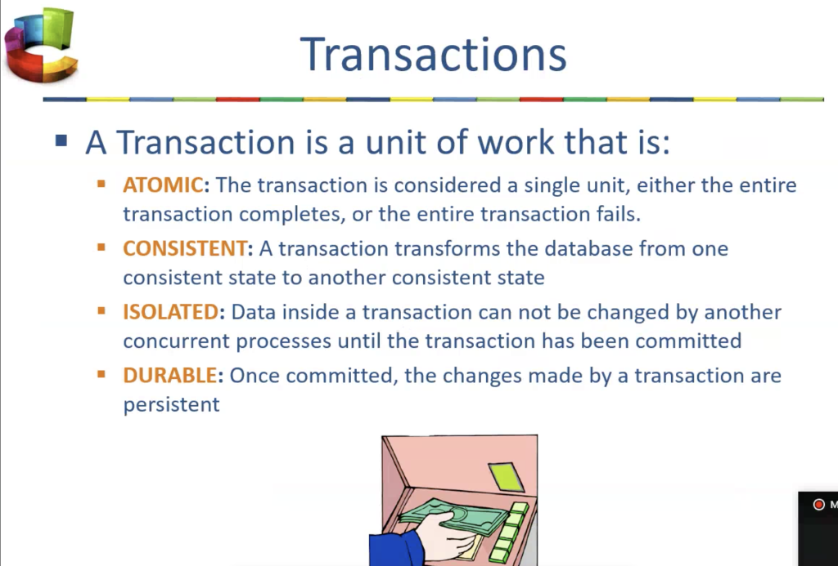

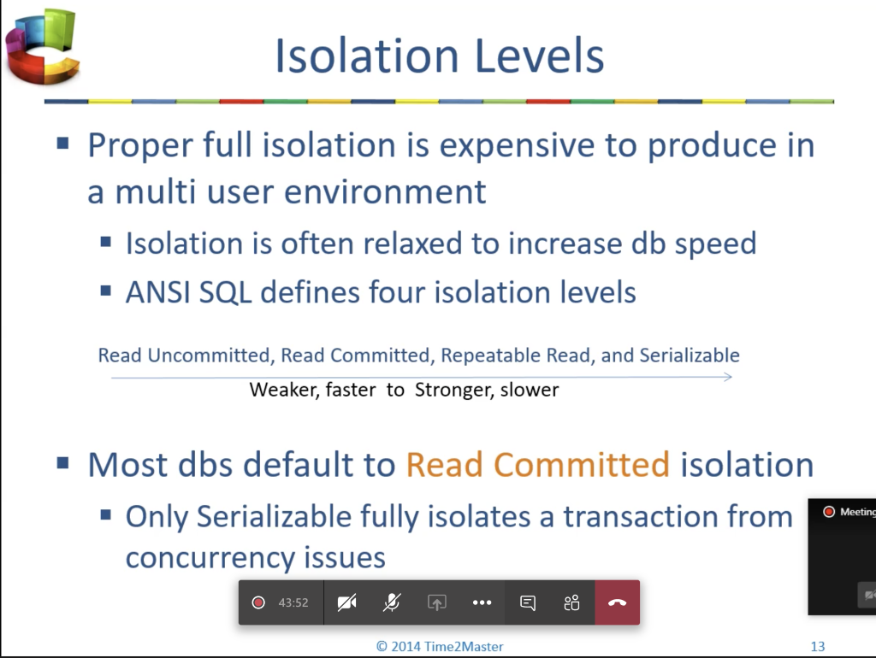

@Transactional(isolation=Isolation.READ_COMMITTED)

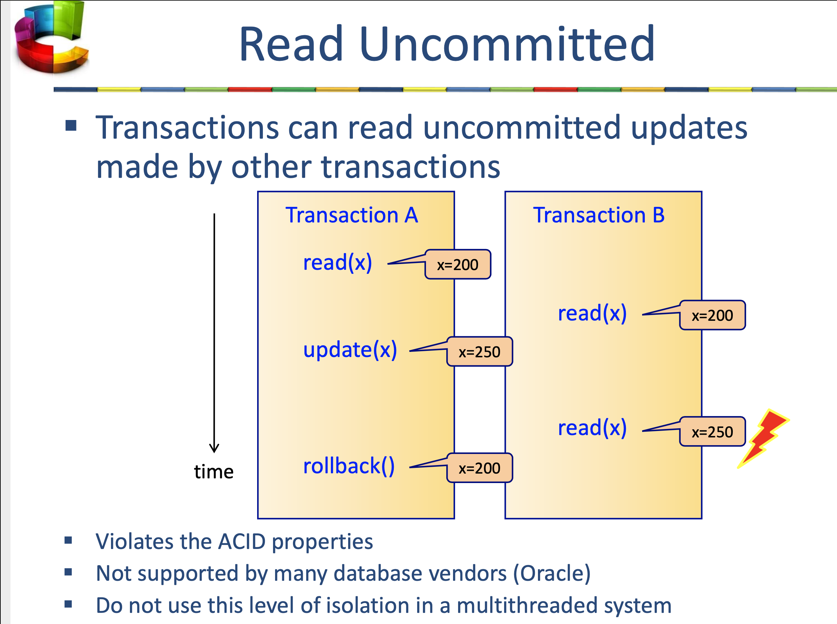

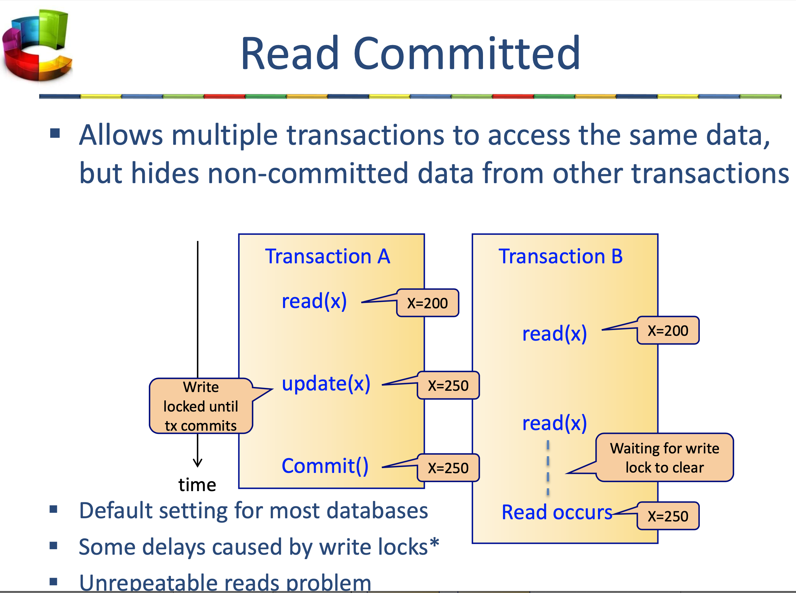

transaction can't read data that is **not** yet committed by other transactions

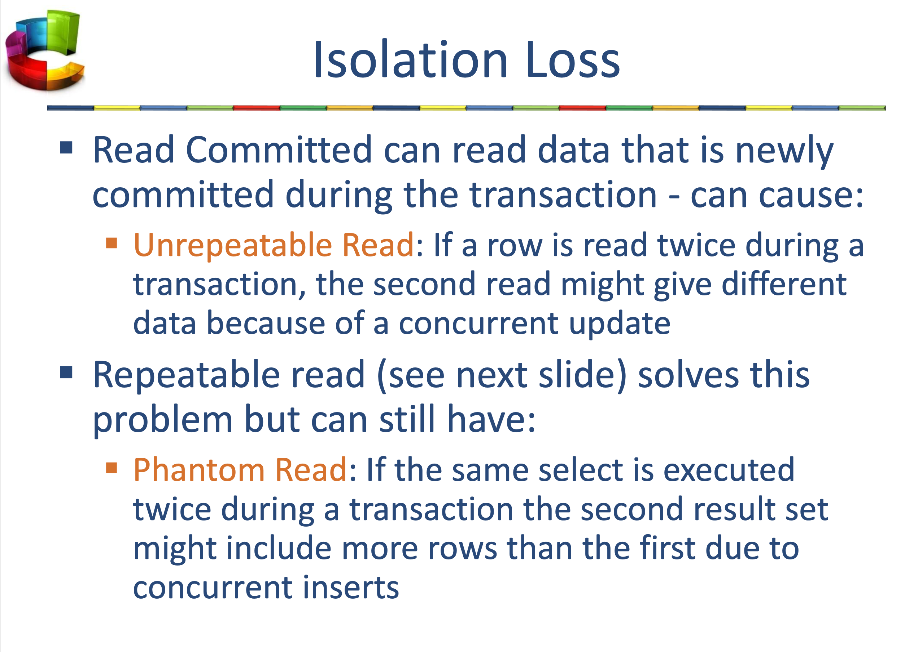

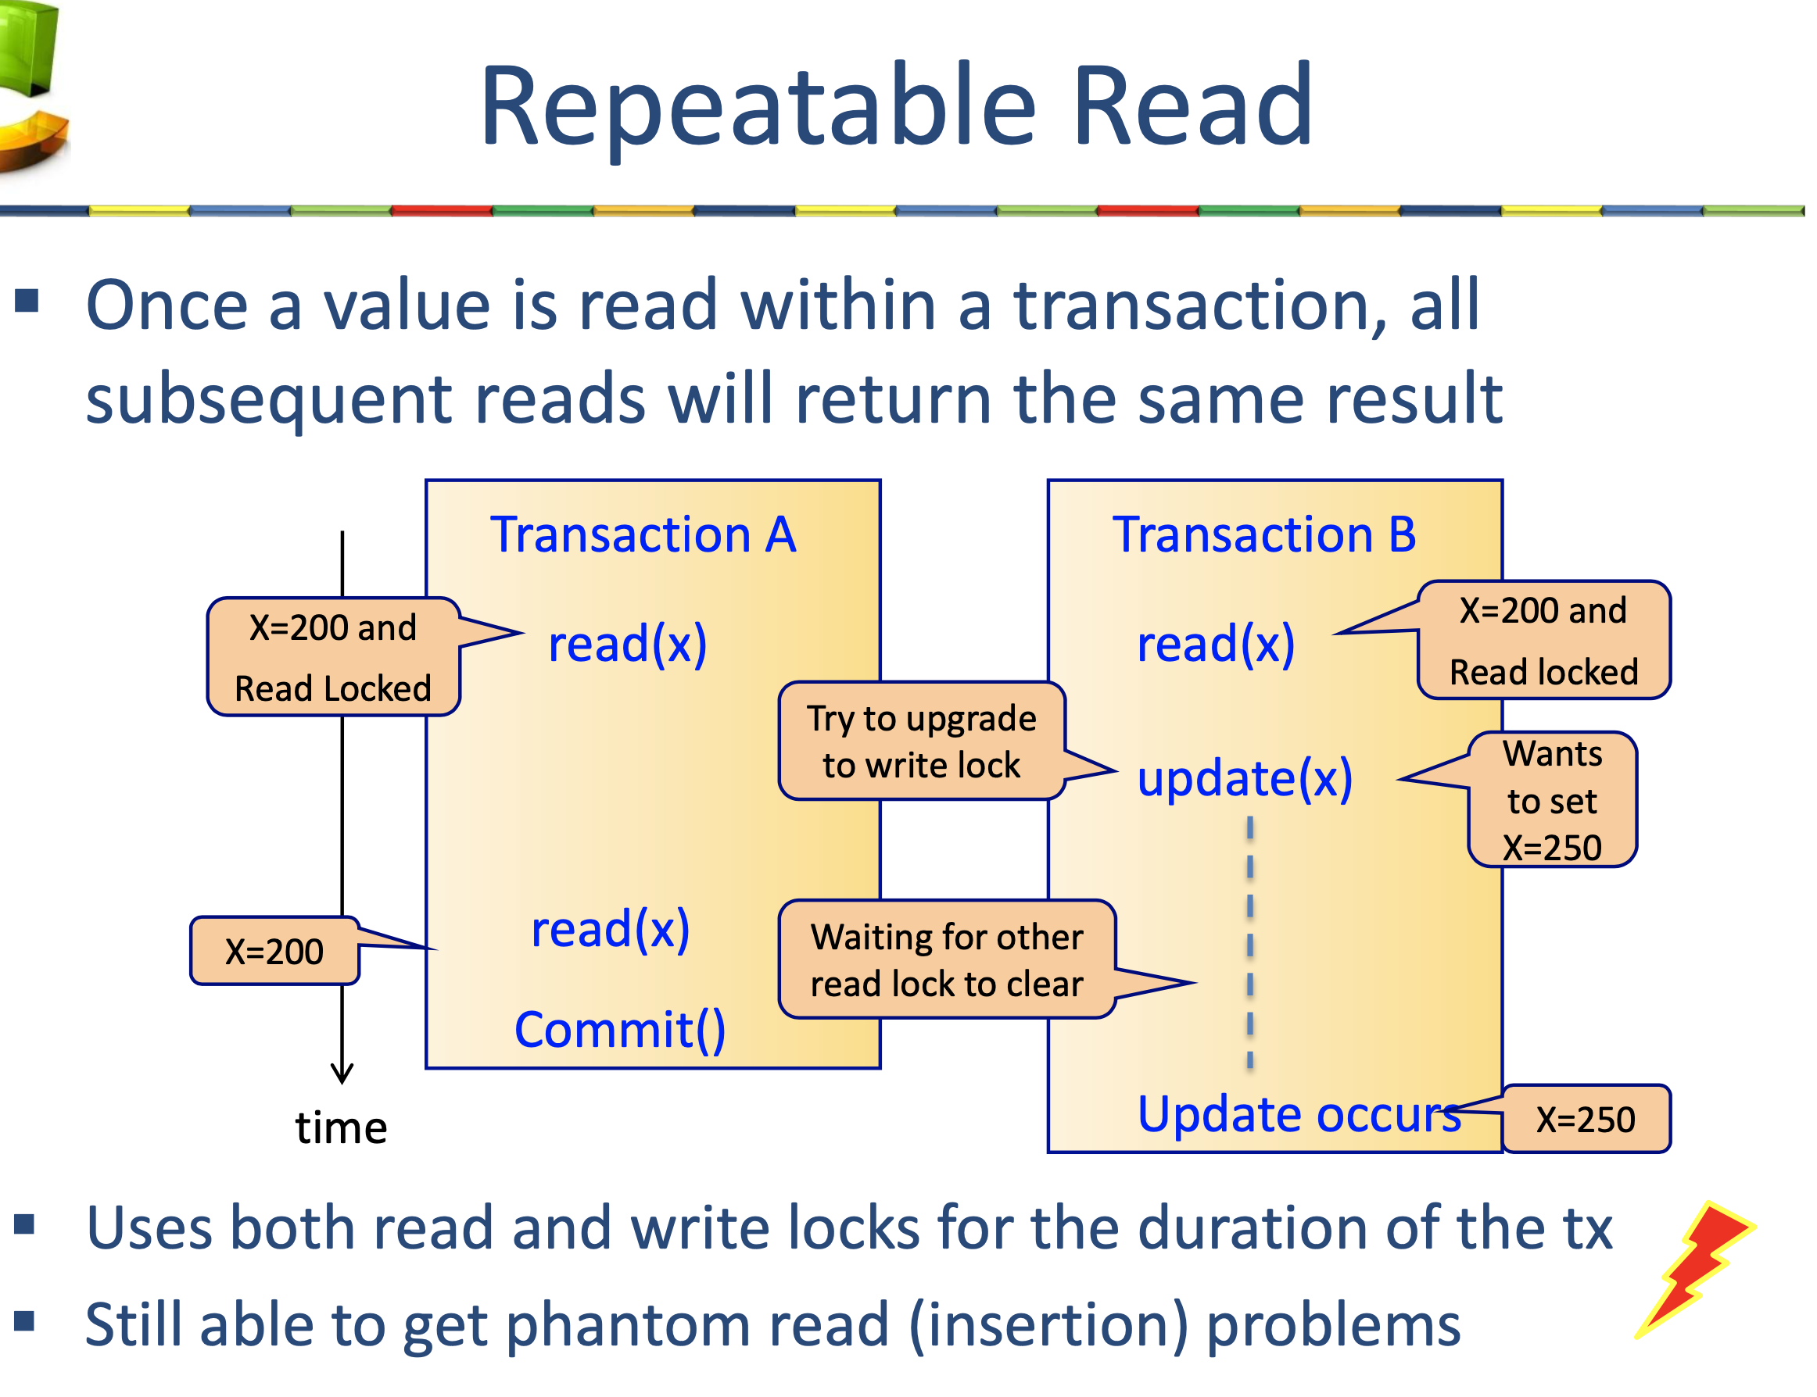

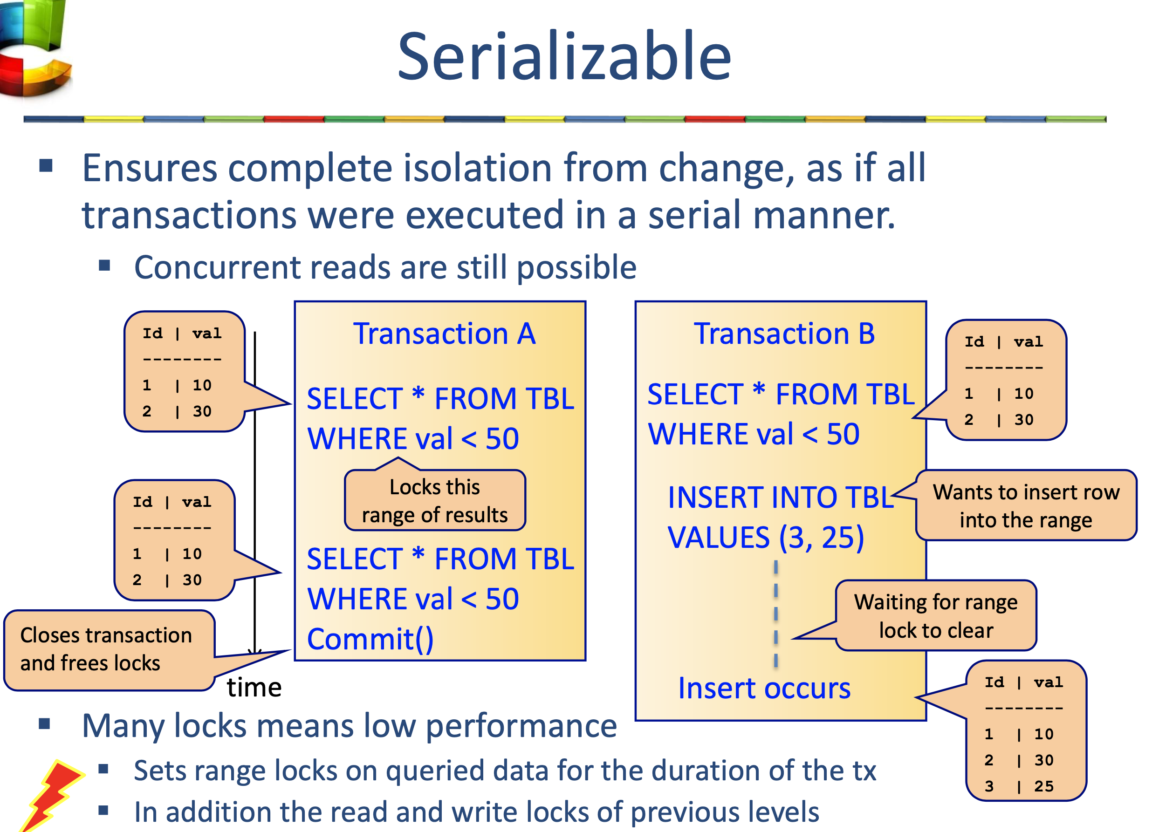

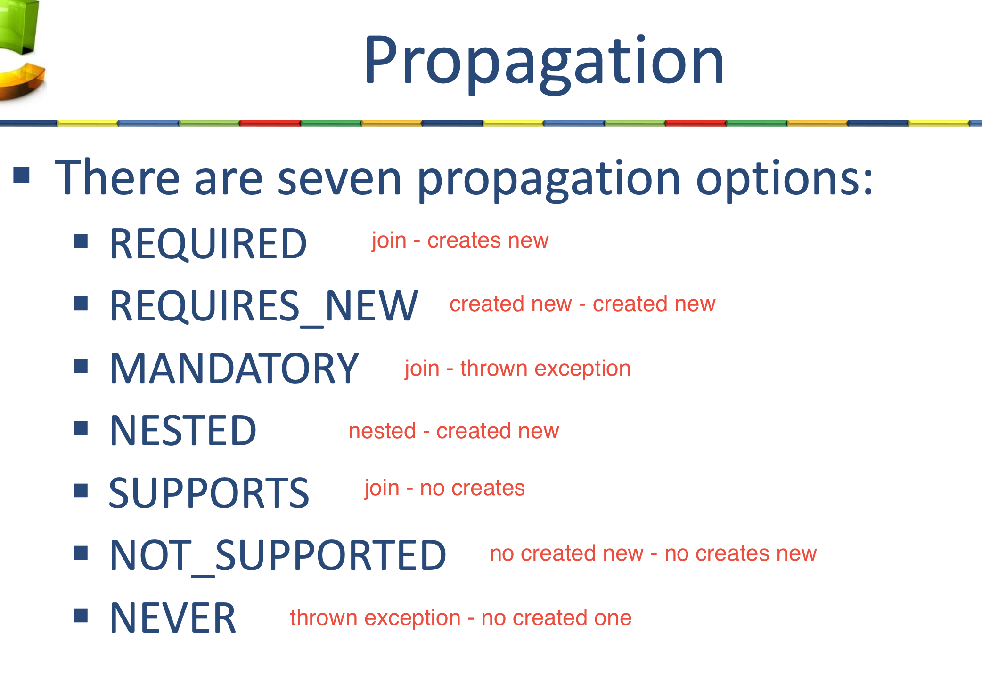

Required.- If the calling method m1() runs in a transaction T1, then method m2() joins the same transaction T1.

If the calling method m1() does not run in a transaction , then method m2() runs in a new created transaction T1

Required_new.- If the calling method m1() runs in a transaction T1, then method m2() runs in a new created transaction T2.

If the calling method m1() does not run in a transaction , then method m2() runs in a new created transaction T1

Mandatory.- If the calling method m1() runs in a transaction T1, then method m2() joins the same transaction T1.

If the calling method m1() does not run in a transaction , an exception is thrown

Nested.- If the calling method m1() runs in a transaction T1, then method m2() runs in a nested transaction T2.

If the calling method m1() does not run in a transaction , then method m2() runs in a new created transaction T1

Supports.- If the calling method m1() runs in a transaction T1, then method m2() joins the same transaction T1.

If the calling method m1() does not run in a transaction , then method m2() also does not run within a transaction

Not_supported.- If the calling method m1() runs in a transaction T1, then method m2() does not run within a transaction.

If the calling method m1() does not run in a transaction , then method m2() also does not run within a transaction

SPRING HIBERNATE

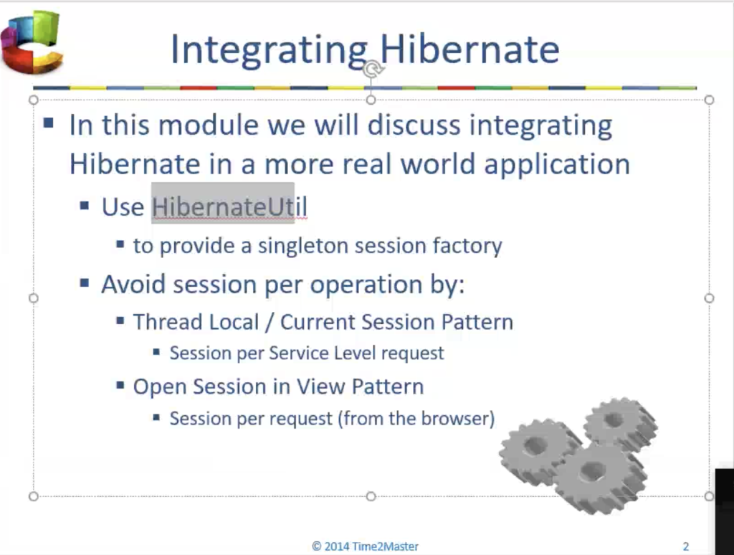

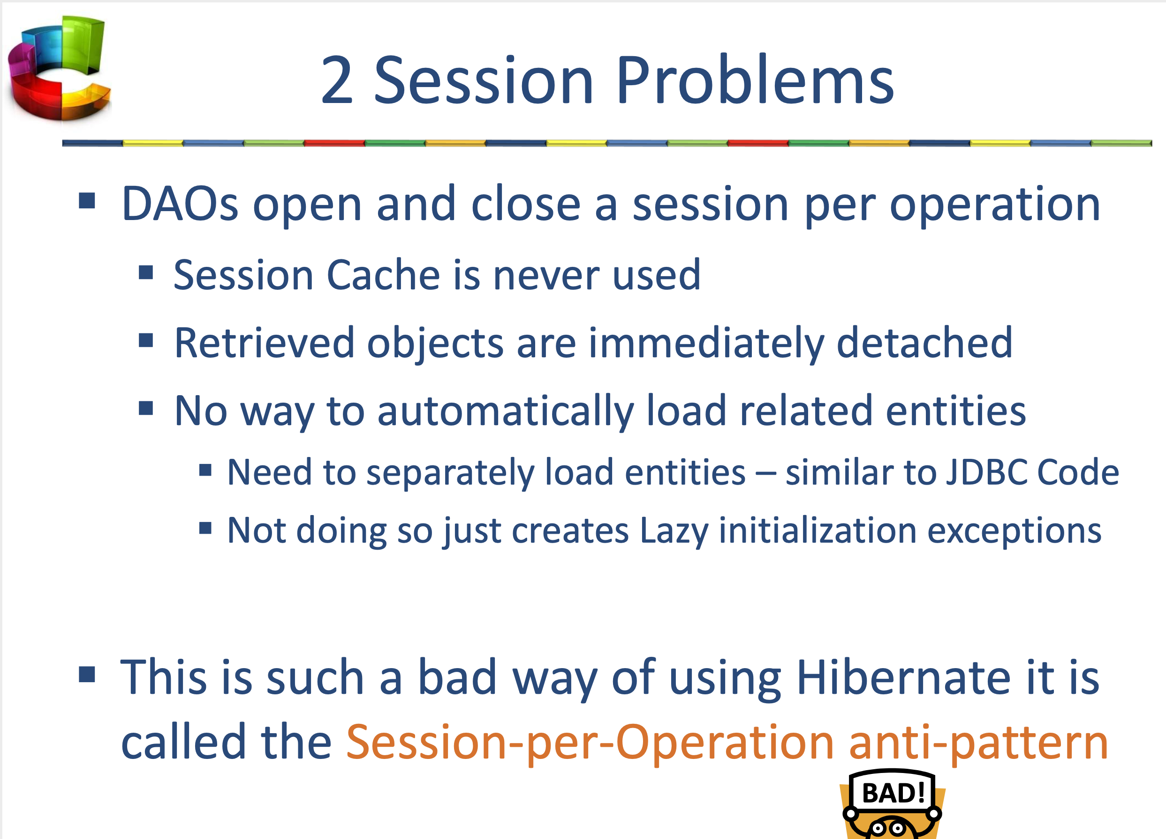

opensessioninview

SPRING MVC

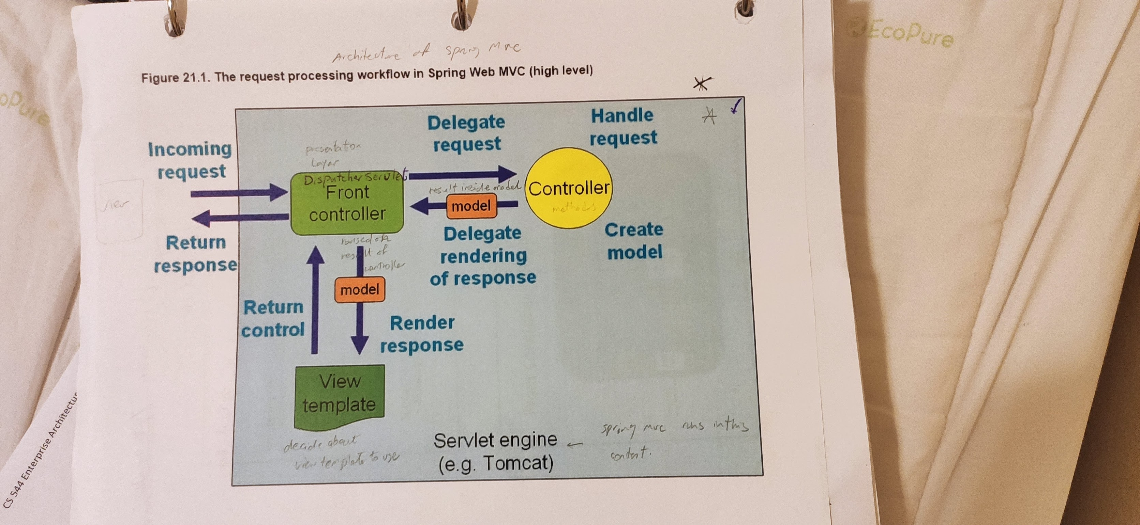

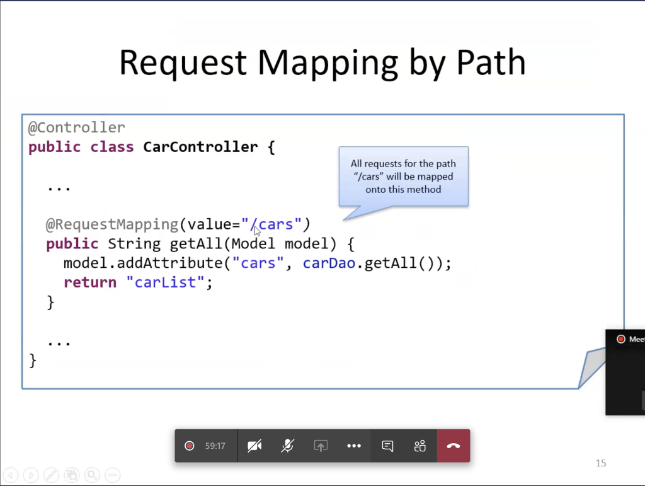

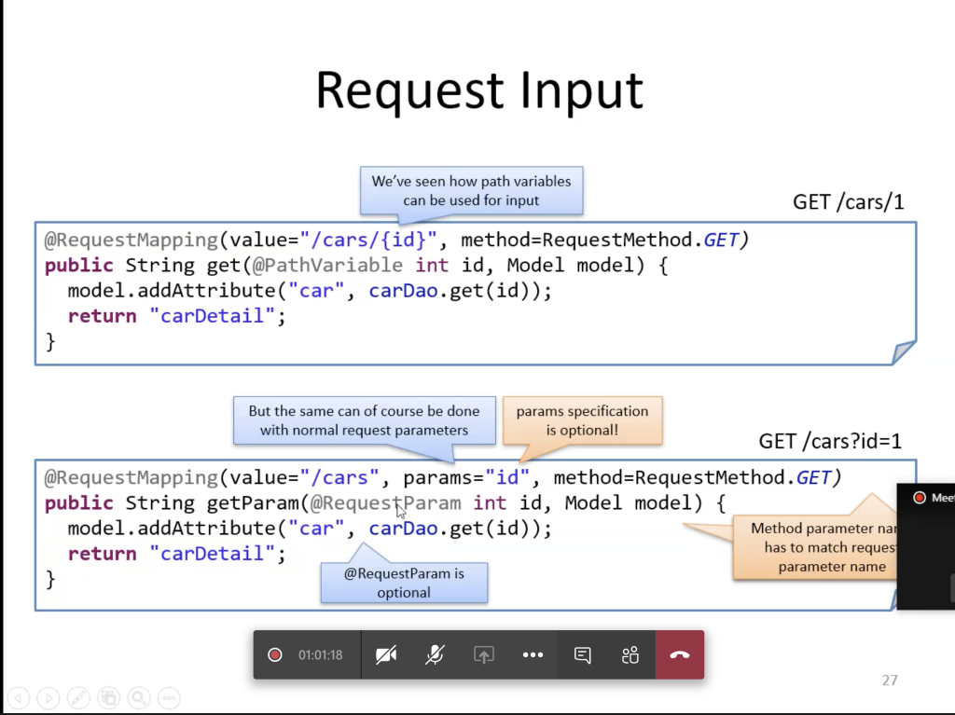

Securiry

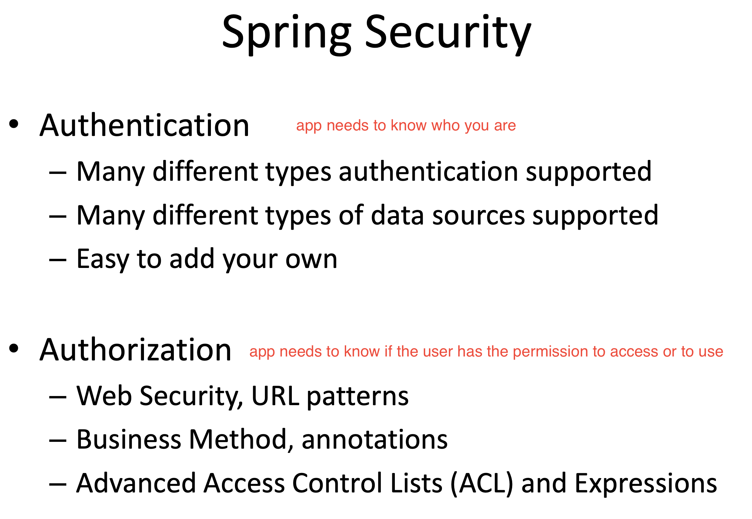

Validation

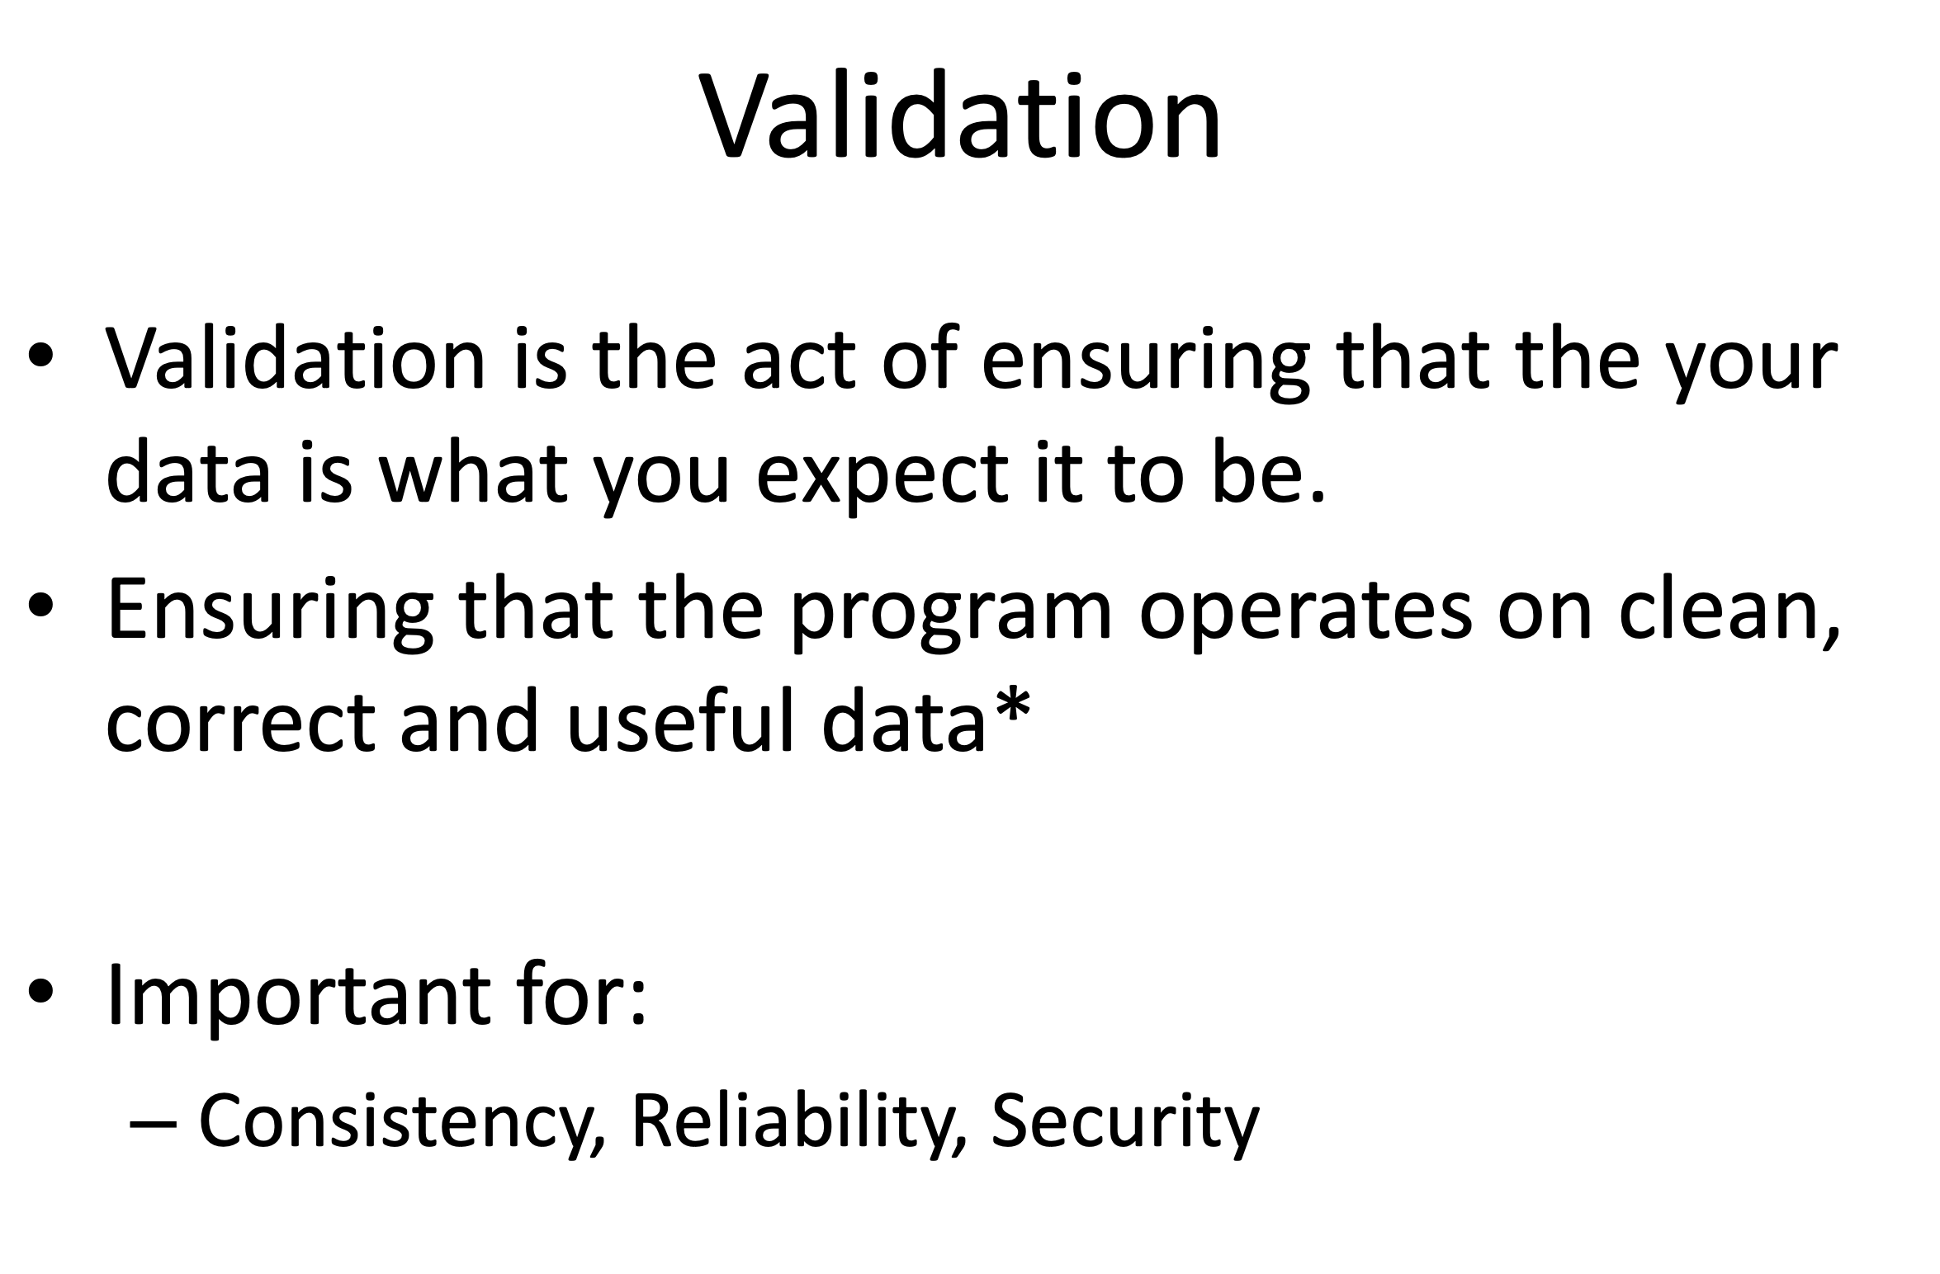

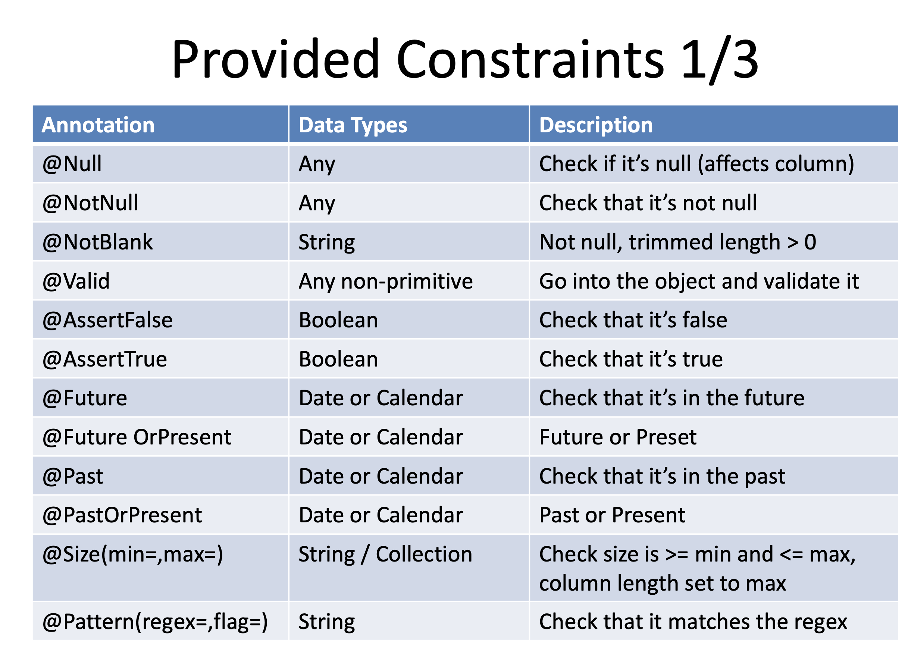

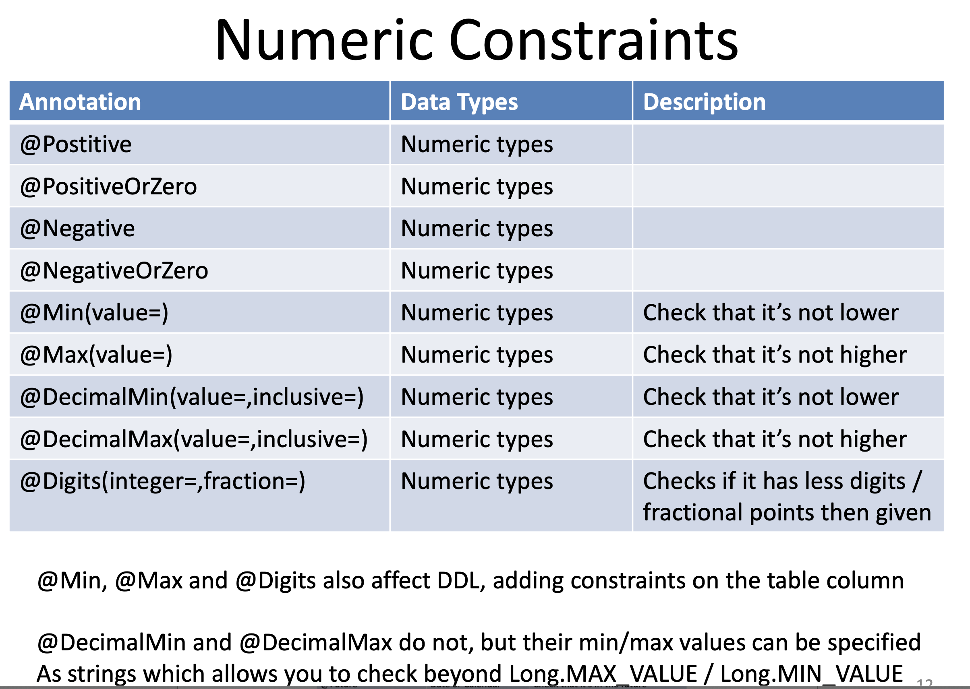

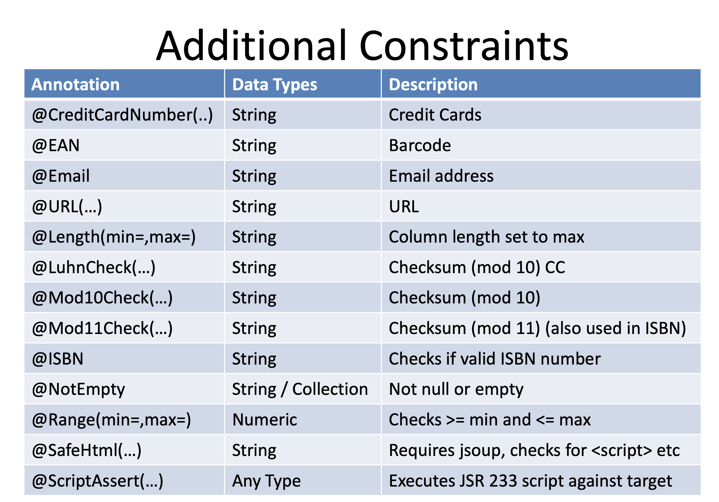

List advantages and disvantages

